This document is written by the Year 3 (2018/2019) Physics students from UCL (University College London) as a part of a Group Project.

Building the small (SS) microscope

These are the instructions that need to be followed to make the OpenFlexure 3D printed microscope after all the plastic parts were printed. The printing requires around 100 grams of plastic. The STL files that are required for 3D printing of all the parts are listed below. They can be found in the open source GitHub repository belonging to Richard Bowman [1]. It also contains all the details about the construction of the microscope and its structure.

Equipment list:

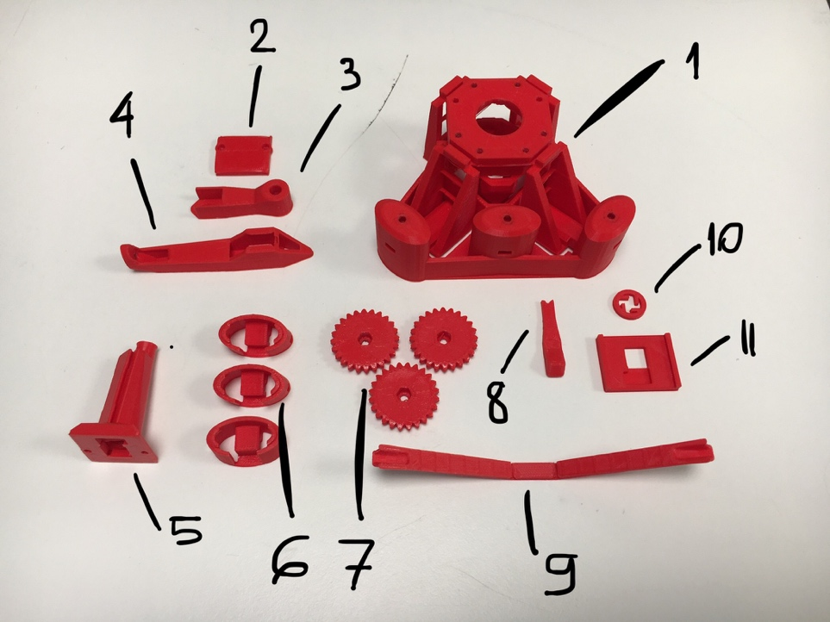

Figure 1. An image of all the 3D printed parts and tools needed to build SS OpenFlexure microscope. The names of all the pieces are listed below.

* 3D printed parts (figure 1):
  + Microscope body (1)
  + Optics module (5)
  + Illumination arm (3)
  + Rear foot (4)
  + Gears x3 (7)
  + Outer feet (tilted) x2 (6)
  + Middle foot (untilted) (6)
  + Raspberry Pi camera cover (2)
  + Sample holder clips x2
* 3D printed tools (figure 1):
  + Band tool (9)
  + Nut tool (8)
  + Camera board gripper (11)
  + Camera lens remover (10)

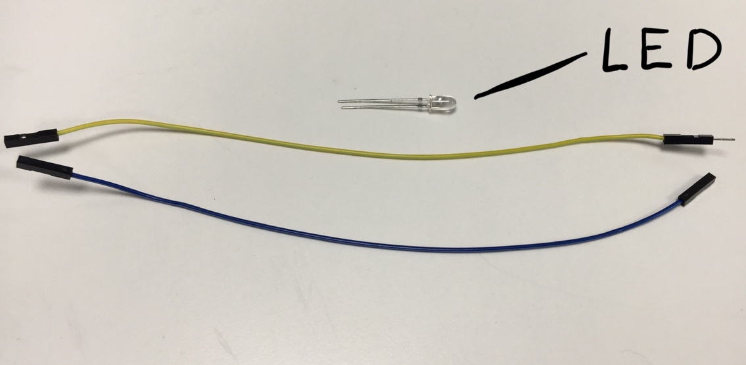

Figure 2. Some electronics needed to build the microscope. Shown: LED, jumping wires with male to female connectors (yellow) and female to female connectors (blue).

* Electronics (figure 2):
  + Jumping wires with female to female x3
  + Jumping wire with female to male x1
  + LED (white) x1
  + Resistor (330 Ohm)
  + Raspberry Pi computer control unit (and all the associated devices) x1
  + Raspberry Pi version 2 camera module (with lens) x1
* Hardware:
  + M3 screws (25 mm) x3
  + M3 screws (8 mm) x4
  + M2 screws (8 mm) x2
  + M3 nuts x6
  + M2 washers x2
  + M3 washers x3
  + Small elastic bands x3
* Tools:
  + Hex key
  + Screwdriver
  + Craft knife

Names of the STL files:

* 3D printed parts:
  + body_SS.stl
  + optics_picam2_pilens.stl
  + illumination_and_back_foot_adj_SS.stl
  + gears.stl
  + sample_clips.stl
  + feet.stl
  + picamera_2_cover.stl
* 3D printed tools:
  + actuator_assembly_tools.stl
  + picam2_lens_remover.stl
  + picam2_board_gripper.stl

Method:

1. Obtain the 3D printed parts and tools. The low-quality mode (0.15 mm layers) should be used to make sure any bridges, that appear during the print, are stable. If Ultimaker 2+ 3D printer is used – all the parts can fit on the printer bed without overlapping, so just one print is sufficient (figure 3). No support material is needed for the printing.

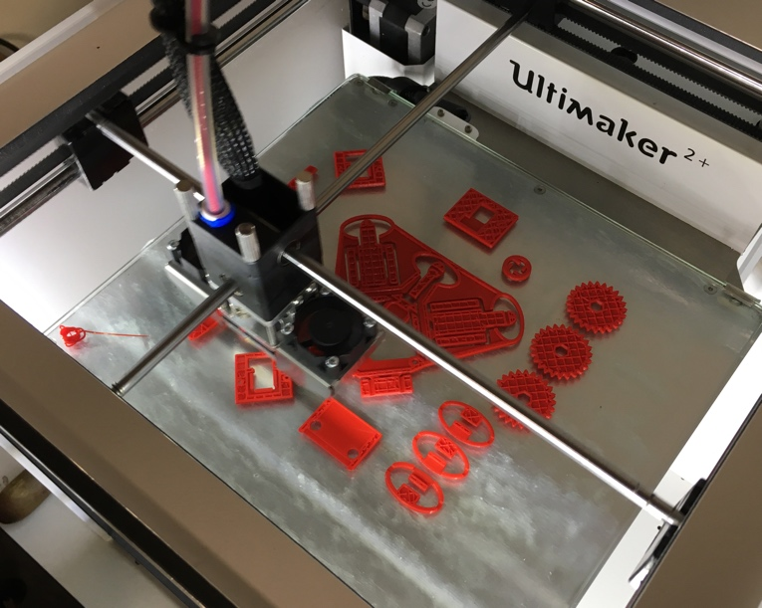

Figure 3. The first few layers printed on the bed of the Ultimaker 2+ 3D printer.

1. Using the band tool snap all the supports that were printed. There are 2 supports in each actuator column and 2 supports linking the mount for the optics module to the microscope body frame.
2. Cut all the loose pieces of plastic which resulted during the printing using the craft knife.
3. Assemble the gears with the elastic bands:
   1. Put the M3 nuts inside the hexagonal holes in the gears (figure 4). Screw the 25 mm M3 screws in the nuts.

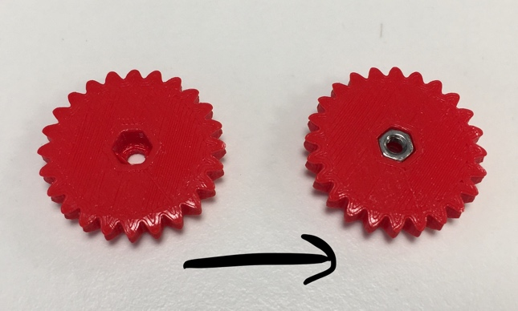

Figure 4. Transition from the freshly printed gear to the gear in which a screw can be screwed in.

* 1. Put another set of the M3 nuts through the holes on the sides of the actuator columns. Each nut should be inserted corner-first to prevent it from jamming.
  2. Place the washers around the holes on top of the actuator columns. Insert the screws through the gears, washers and holes (on top of the actuator columns). Screw them in loosely into the nuts that are inside the actuators. Use the nut tool to hold the nuts tight in place one by one while doing this. This is shown in detail in figure 5.

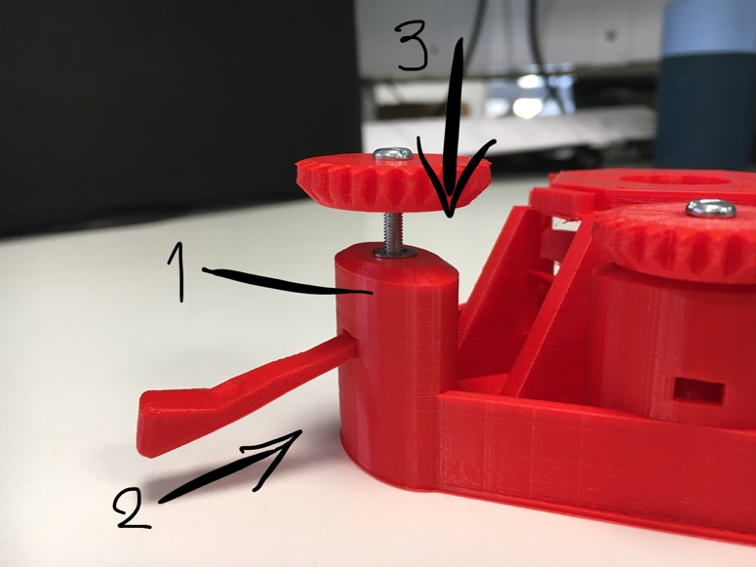

Figure 5. 1 – actuator column, 2 – nut tool holding a nut in place, 3 – screw in.

* 1. Fit the outer and middle feet to the bottom of the microscope. Hook the elastic bands over the ends of the band tool and put them through the microscope feet one by one. The band should grab the hooks and click inside the actuator column. The band pulls the actuator down and the gear should feel more resistance when it is turned. This part is vital for focus control and navigation through a slide with a sample on it (by turning the gears).
  2. The middle part of the bands should hold the feet of the microscope in place (figure 6). Make sure all 3 actuators are done correctly.

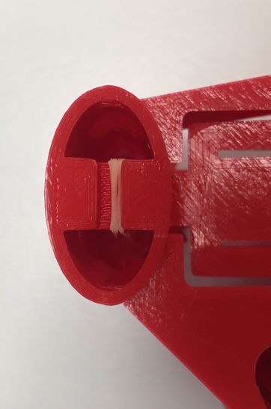

Figure 6. The orange band (under tension) is holding the foot in place.

1. Assemble the illumination module:
   1. Take the rear foot and thread the jumping wires with female to female connectors through the opening in the foot.
   2. Screw the horizontal illumination arm to the vertical rear foot using the M3 8mm screw, the nut and the washer (figure 7). Put the end of the jumping wire through the opening in this part.

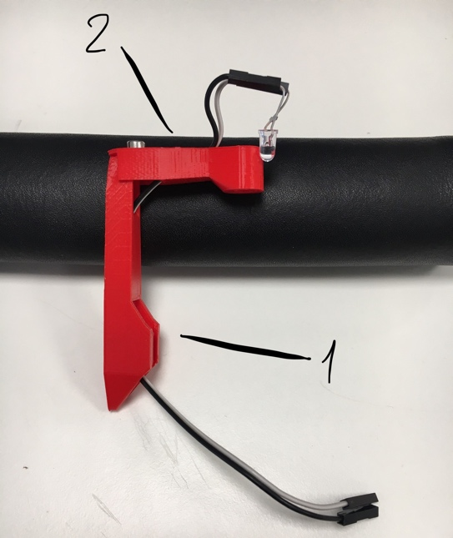

Figure 7. Illumination module: 1 – rear foot, 2 – illumination arm.

* 1. Connect the LED to the jumping wires and fit it into the light bulb opening in the horizonal illumination arm.
  2. Connect the 330 Ohm resistor to one of the wires sticking from the bottom of the illumination arm. Connect another female to female jumping wire to the other end of the resistor and a male to female wire to the unused connector of the second wire.
  3. Connect both of the wires to the Raspberry Pi control unit.
  4. Slide on the illumination module on to the dovetail mount at the back of the microscope body (figure 8). Make sure it is slid from the bottom.

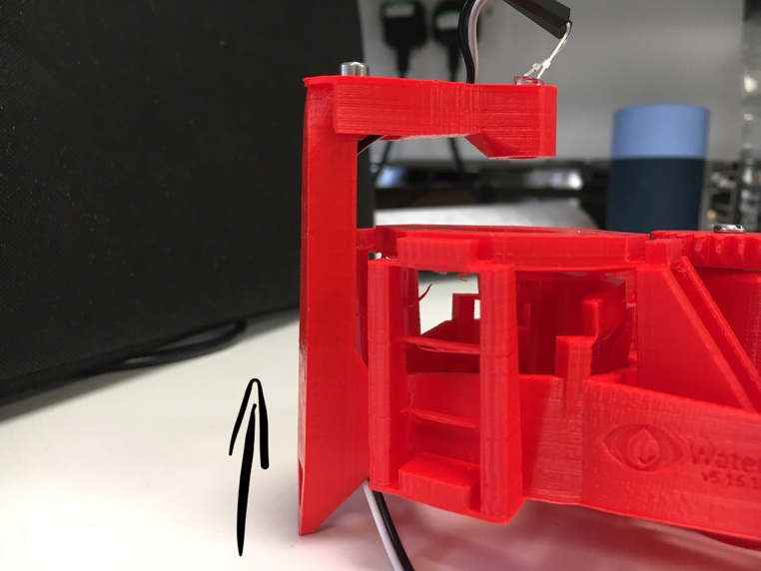

Figure 8. Sliding the illumination module into the microscope body from the bottom.

1. Integrate the Raspberry Pi camera module with the optics module. This has to be done carefully as the camera sensor is very sensitive and the lens is very fragile:
   1. Remove the protective film from the camera lens.
   2. Fit the lens on the camera module through the opening in the camera board gripper so the camera module is static.
   3. Put the camera lens remover over the lens. The hooks on the remover should be pointing anti-clockwise. Turn the remover to unscrew the lens making sure that the board gripper is holding the camera module in place.
   4. Carefully take the lens that has just been removed and fit it on top of the optics module (figure 9). This requires a bit of force. Make sure the lens is the same way up as it was on the camera module.

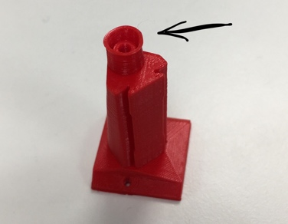

Figure 9. The lens from the Raspberry Pi camera module must be fit in the opening.

* 1. Put the rest of the camera module under the optics module making sure that it fits in the hole which is designed specifically for this camera model. Put the camera cover over it and screw the 8 mm M2 screws in to hold it tight in place. The detailed overview can be found in figure 10.

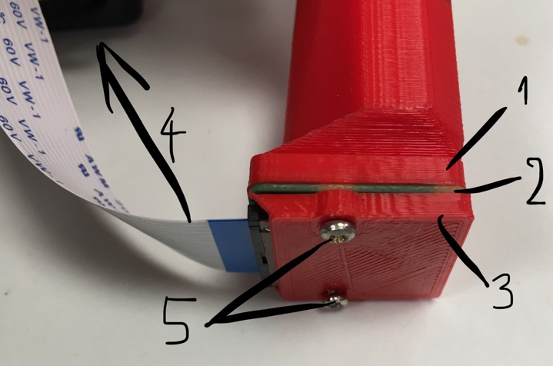

Figure 10. Integration of the Raspberry Pi camera module with the optics module. 1 – optics module, 2 – camera module, 3 – camera cover, 4 – to the Raspberry Pi control unit, 5 – M2 screws.

* 1. Slide the optics module in the opening in the microscope body onto the dovetail mount (figure 11) and connect the camera module to the Raspberry Pi control unit.

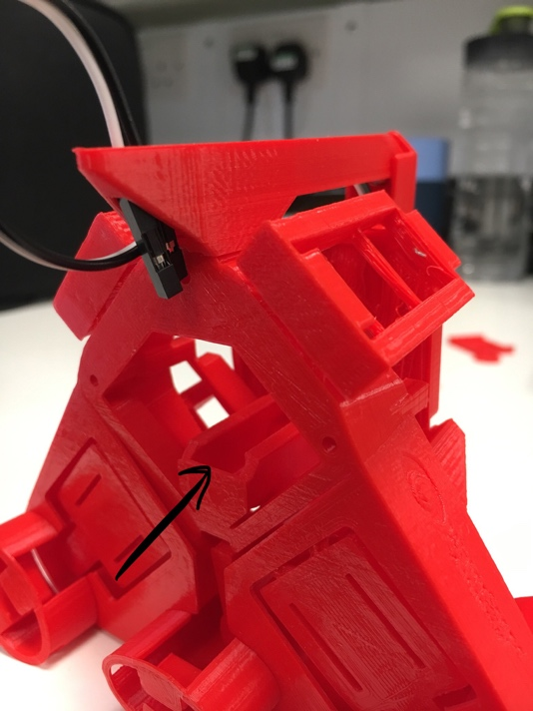

Figure 11. Dovetail mount in the microscope body for the optics module.

1. Screw the sample holder clips in the holes on the top of the microscope body using 8mm M3 screws.

Building the larger (LS65) microscope

To make the larger (LS65) microscope, the same instructions need to be followed with some minor changes and additions. Moreover, another set of the 3D printed parts are needed (described later). Most of the 3D printed parts are different than the ones for the smaller microscope. The parts are bigger and thus are taking longer to print. As before, all the details about the structure and the parts can be found in the Richard Bowman’s GitHub repository [1]. Figure 12 shows both SS and LS65 microscopes standing side by side.

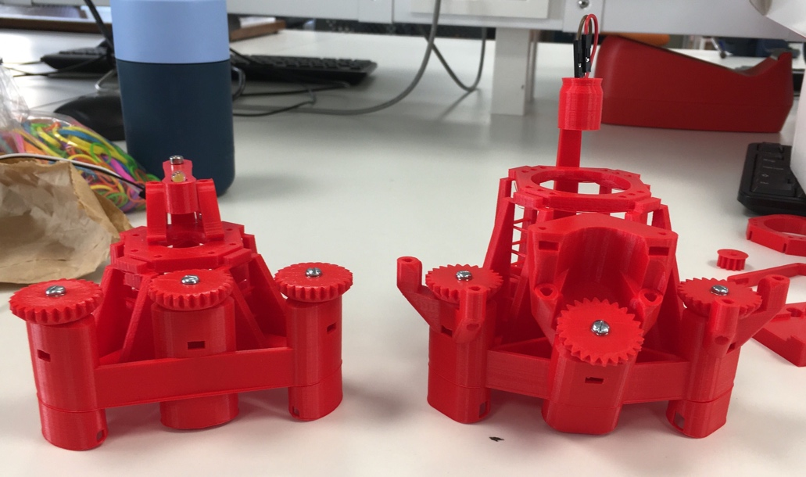

Figure 12. Smaller SS (left) and larger LS65 (right) OpenFlexure microscopes. The LS65 microscope is missing sample clips (used in the SS microscope).

Extra equipment list:

* Illumination head (figure 13)
* M3 screw (8mm) x1
* M3 head x1

Names of the STL files:

* 3D printed parts:
  + main_body_LS65-M.stl
  + optics_picamera_2_pilens_LS65.stl
  + illumination_and_rear_foot_LS75.stl
  + gears.stl
  + small_gears.stl
  + sample_clips.stl
  + feet.stl
  + picamera_2_cover.stl
* 3D printed tools:
  + actuator_assembly_tools.stl
  + picam2_lens_remover.stl
  + picam2_board_gripper.stl

Changes in the method:

* Step 5 (assembling the illumination module):
  + Illumination head should be slid on to the dovetail mount on the illumination arm.

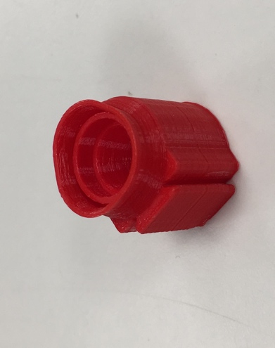

Figure 13. Illumination head.

* + The LED is then placed in the head.
* Step 6 (optics module):
  + The optics module for the larger microscope looks a bit different comparing to the smaller one.
  + The M3 nut is placed in the small pocket on the side of the optics module (figure 14 (1)).
  + The 8mm M3 screw is then screwed in this nut through the hole that was specifically designed for this (figure 14 (2)).

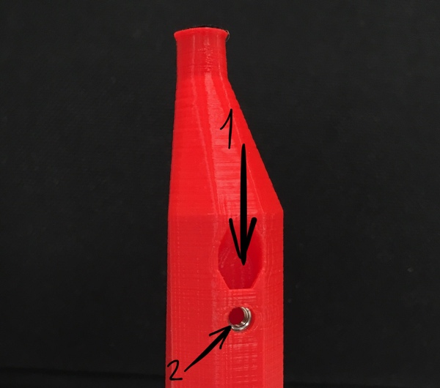

Figure 14. The top of the LS65 optics module. 1 – a pocket for M3 nut, 2 – a hole for M3 screw.

* + When the optics module is integrated with the main body of the microscope, the screw is placed into the internal slit on the inside of the body. This is done going from the bottom upwards.

References

[1] https://github.com/rwb27/openflexure_microscope